

E-Commerce Web Application

Project Planning Document

Version: 1.0

Date Created: 01/05/2019

Table of Contents

1. Stakeholders Description 3

2. Process Model and Justification 4

3. Work Breakdown Structure 4

4. Milestones and deliverables 7

5. Activity Dependencies 7

6. Project Schedule 8

7. Risk Management Analysis 9

List of Figures

**Figure 1: Gantt chart** 8

**Figure 2: Activity Network** 9

List of Tables

**Table 1: List of milestones and deliverables** 7

**Table 2: Activities and dependencies** 7

1. Stakeholders Description

|  |  |  |
| --- | --- | --- |
| **S. No.** | **STAKEHOLDERS** | **REQUIREMENTS** |
| **1** | Customers | 1. **View products** 2. **Filter products by categories** 3. **Filter products by subcategories** 4. **Filter products by brand** 5. **Buy Products** 6. **View products in cart** 7. **Change order details in cart** 8. **Place order** 9. **Do payments for products** 10. **View previous orders** 11. **View order receipts** 12. **Print order receipts** 13. **Receive order confirmation message** 14. **Receive order receipts on mail** |
| **2** | Vendors | 1. **Add products in database** 2. **View orders placed by customers** 3. **View order receipts.** 4. **Print order receipts.** 5. **Add products in bulk (through excel sheet)** 6. **Modify product details.** 7. **Delete products from database.** |
| **3** | Administrator (Master) | 1. **Add categories and sub-categories in database** 2. **Add user and vendors** 3. **Modify user status** 4. **View all users of the application** 5. **Remove user from the application** 6. **View all categories and sub-categories in the database.** 7. **Add privileges for the vendors.** 8. **Modify privileges for the vendors** 9. **Delete privileges of the user.** 10. **View invoices details.** 11. **Print all the invoices details.** |

1. Process Model and Justification

Iterative model is to be used for this project as it will suit the best for this project as per the requirements. As our application is divided into several module, so, we have to build it partially, module-wise and then integrate to reach our final application goal. The advantage of using iterative model in this application is that, our system can have risk management and individual module can be tested in each build phase. Other than that, testing individual module will be much easier and after every testing phase, we can combine the modules for integration testing. After successful integration testing, we can proceed to another build, without affecting our previous application.

1. Work Breakdown Structure

TASK 1: Setting up work environment

TASK 1.1: Understanding requirements

TASK 1.2: Installing necessary softwares/applications

TASK 1.3: Gathering resources and setting up.

TASK 2: Creating user addition module

TASK 2.1: Creating Login/Signup page

TASK 2.2: Creating tables in database

TASK 2.3: Setting up constraints

TASK 2.4: Testing the developed module

TASK 3: Creating Customer Module

TASK 3.1: Creating product addition to cart module

TASK 3.1.1: Create tables in database

TASK 3.1.2: Define constraints in database

TASK 3.1.3: Create product display page

TASK 3.1.4: Create customer cart

TASK 3.2: Creating payment portal module

TASK 3.2.1: Setup payment page

TASK 3.2.2: Setup email-confirmation module

TASK 3.2.3: Setup message-confirmation module

TASK 3.3: Creating previous orders module

TASK 3.3.1: Create front-end page

TASK 3.3.2: Create tables in database

TASK 3.3.3: Create back-end part

TASK 3.4: Creating order receipt viewing module

TASK 3.4.1: Create front-end page

TASK 3.4.2: Create tables in database

TASK 3.4.3: Create back-end part

TASK4: Creating Vendor Module

TASK 4.1: Creating product addition module

TASK 4.1.1: Create tables in database

TASK 4.1.2: Define constraints in database

TASK 4.1.3: Create product addition forms

TASK 4.1.4: Create form submission backend part

TASK 4.2: Creating product update module

TASK 4.2.1: Setup product update frontend page

TASK 4.2.2: Create update details backend

TASK 4.3: Creating products delete module

TASK 4.3.1: Create front-end page

TASK 4.3.2: Create delete product backend

TASK 4.4: Creating orders view module

TASK 4.4.1: Create front-end page

TASK 4.4.2: Create backend for viewing orders

TASK 4.4.3: Create print module

TASK5: Creating Administrator Module

TASK 5.1: Creating category/subcategory addition module

TASK 5.1.1: Create tables in database

TASK 5.1.2: Define constraints in database

TASK 5.1.3: Create front end for viewing all categories and subcategories

TASK 5.1.4: Create categories & subcategories addition forms

TASK 5.1.5: Create form submission backend part

TASK 5.2: Creating user management module

TASK 5.2.1: Create front end for viewing all users.

TASK 5.2.2: Create forms for user addition, user updating and details editing.

TASK 5.2.3: Create form submission backend part

TASK 5.3: Creating access management module

TASK 5.3.1: Create tables in database

TASK 5.3.2: Define constraints in database

TASK 5.3.3: Create front end for viewing all menus and submenus

TASK 5.3.4: Create privileges (menus) addition form, editing privileges form and deleting privilege form

TASK 5.3.5: Create form submission backend part

TASK 5.4: Creating invoice viewing module

TASK 5.4.1: Create form for submitting user name for particular invoice.

TASK 5.4.2: Create front end for viewing all invoices

TASK 5.4.3: Create form submission backend part.

TASK 5.4.4: Create front end for viewing invoices for particular user

1. Milestones and deliverables

**Table 1: List of milestones and deliverables**

|  |  |
| --- | --- |
| **MILESTONES** | **DELIVERABLES** |
| Getting requirements | ------ |
| Risk Analysis and management- I | Project Planning Document |
| Bundling software requirements |  |
| Preparing SRS document | SRS document |
| Building work flow of design and development | ------ |
| Preparing SDS document | SDS document |
| Completion of TASK 1 |  |
| Testing and debugging – I | Test report- I , Prototype - I |
| Completion of TASK 2 |  |
| Testing and debugging –II | Test report - II |
| Integration testing- I | Prototype – II |
| Completion of TASK 3 |  |
| Testing and debugging –III | Test report - III |
| Integration testing- II | Prototype – III |
| Completion of TASK 4 |  |
| Testing and debugging –IV | Test Report - IV |
| Integration testing- III | Prototype – IV |
| Completion of TASK 5 |  |
| Testing and debugging –V | Test Report - V |
| Integration testing- IV | Prototype – V |
| Software Testing and Debugging | Full version of software (to be hosted) |

1. Activity Dependencies

**Table 2: Activities and dependencies**

|  |  |  |  |
| --- | --- | --- | --- |
| TASK | LABEL | PREDECESSOR | ESTIMATED DURATION (DAYS) |
| Getting requirements | A | ------ | 4 |
| Risk Analysis and management- I | B | A | 3 |
| Bundling software requirements | C | A | 4 |
| Preparing SRS document | D | B, C | 2 |
| Building work flow of design and development | E | D | 3 |
| Preparing SDS document | F | E | 2 |
| Completion of TASK 1 | G | F | 3 |
| Testing and debugging – I | H | G | 2 |
| Completion of TASK 2 | I | F | 3 |
| Testing and debugging –II | J | I | 2 |
| Integration testing- I | K | H,J | 3 |
| Completion of TASK 3 | L | F | 3 |
| Testing and debugging –III | M | L | 2 |
| Integration testing- II | N | K, M | 3 |
| Completion of TASK 4 | O | F | 3 |
| Testing and debugging –IV | P | O | 2 |
| Integration testing- III | Q | N, P | 3 |
| Completion of TASK 5 | R | F | 3 |
| Testing and debugging –V | S | R | 2 |
| Integration testing- IV | T | Q, S | 3 |
| Software Testing and Debugging | U | T | 3 |

1. Project Schedule

**Figure 1: Gantt chart**

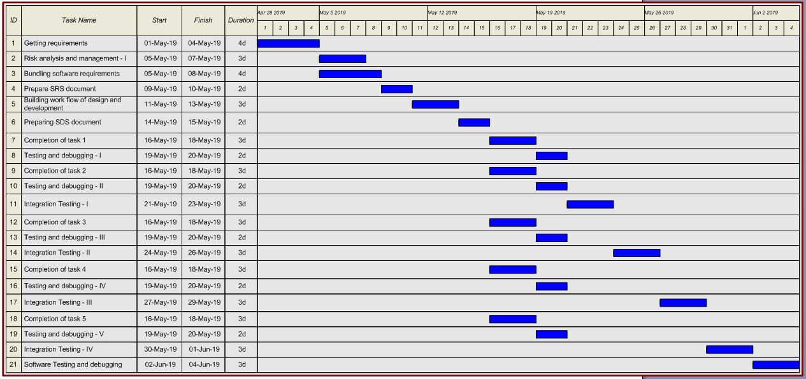

**Figure 2: Activity Network**

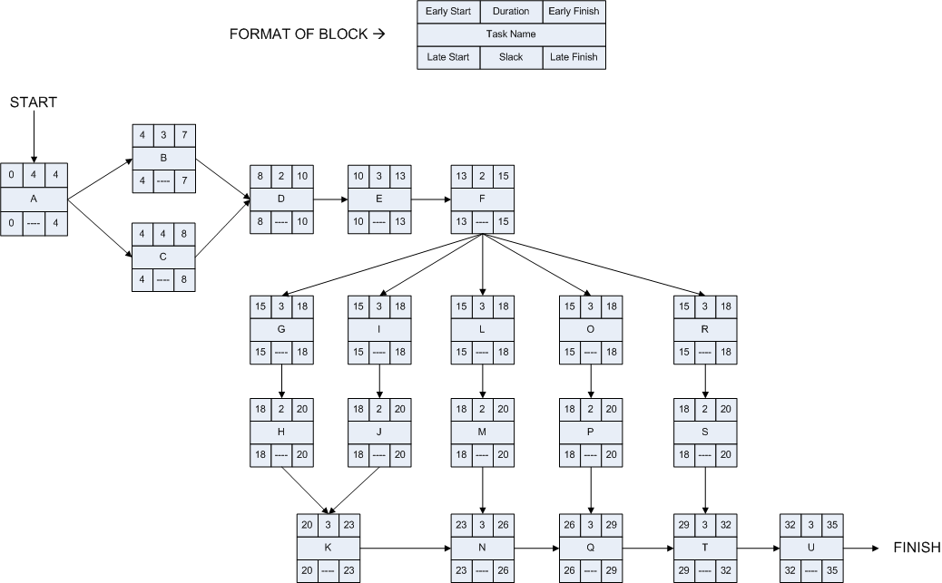

1. Risk Management Analysis

|  |  |  |  |
| --- | --- | --- | --- |
| **RISK TYPE** | **RISKS** | **PROBABILITY** | **EFFECTS** |
| **PEOPLE RISK** | Project Staff is ill at crucial time | **Medium** | **Serious**   1. Project can get delayed 2. It can affect other queued up processes |
| Project staff require some extra training sessions for some functionality understanding | **Low** | **Serious**   1. Project will not be completed in due time. 2. Additional requirements can also emerge. |
| **TECHNOLOGY RISK** | Technology components are not fit for purpose | **Medium** | **Catastrophic**   1. It can result in modification of user’s requirement 2. It will reduce the quality of the software. |
| Technology components are not reliable | **Low** | **Catastrophic**   1. System may crash anytime. 2. Data loss can occur |
| **ORGANIZATIONAL RISKS** | The product fails to match the organization’s culture | **Medium** | **Catastrophic**   1. Company or organization can ask to make certain changes which may affect the overall software 2. Project can get delayed |
| Changes in company norms and conditions | **Low** | **Serious**   1. Company may give some extra requirements. 2. We have to make certain changes in the overall software which may affect some other functionalities |
| **REQUIREMENTS RISK** | Customer or organization can’t express the requirements properly | **High** | **Serious**   1. We have to do some extra work and use extra resources to figure out requirements 2. If it happens repeatedly, it can cause regular delay in the project. |
| Customer requirements not satisfying legal norms and conditions | **Low** | **Catastrophic**   1. It will only lead to cancellation of that requirement. 2. It may affect other requirements and functionalities also. |